

DATA ENGINEER INTERNSHIP
TECHNICAL ASSESSMENT

SHEHAN UYANWATTE
MARKET INTELLIGENCE REPORT: AIRBNB ECOSYSTEM IN LONDON

Contents

- Executive Summary
- Objectives and Scope
- Dataset Overview
- Methodology
- Engineering Approach
- EDA Findings
- Recommendations
- Limitations and Caveats
- Future Improvements
- Reflection
- AI Usage Disclosure

- Executive Summary

1.1 Dataset Overview

This report analyzes the London Airbnb dataset through three key phases: dataset familiarization, data engineering, and exploratory data analysis. The dataset comprises over 96,000 listings, 35 million calendar records, and 2 million reviews, providing comprehensive insight into listing characteristics, host behavior, pricing patterns, availability, and customer engagement across London. During the familiarization phase, the dataset structure, relationships, primary and foreign keys, and business context were examined to establish a foundation for subsequent analysis.

1.2 Data Quality and Engineering

The data engineering process focused on profiling dataset attributes, identifying relationships between tables, and evaluating overall data quality. Several challenges were identified, including missing values in critical attributes such as price, neighbourhood information, and licensing data, as well as inconsistencies in data types and ambiguous fields across multiple files. While the majority of records were complete and suitable for analysis, these quality issues highlighted the importance of data cleansing and standardization to ensure reliable analytical outcomes and improve the accuracy of future predictive models.

1.3 Key Analytical Findings

Exploratory data analysis revealed significant variation in pricing across London boroughs, room types, and property categories. Premium central locations such as Westminster and Kensington & Chelsea consistently commanded higher prices, while outer boroughs offered more affordable accommodation options. The market demonstrated a strong right-skewed distribution, where a relatively small number of luxury properties and professional hosts generated a disproportionate share of listings and revenue. Seasonal analysis further indicated that host minimum-night requirements remain relatively stable throughout the year, despite fluctuations in demand and occupancy levels.

1.4 Business Insights

The findings highlight a highly concentrated marketplace where professional multi-property operators control a substantial portion of available inventory, despite single-property hosts representing the majority of host accounts. Furthermore, listings with competitive pricing structures were observed to attract higher review volumes and stronger booking activity, emphasizing the relationship between affordability and market performance. Overall, the analysis provides valuable insight into the operational structure, pricing dynamics, and supply-side characteristics of the London Airbnb ecosystem while demonstrating the importance of robust data preparation practices in supporting data-driven decision-making.
- Scope and Objectives

2.1 Scope

The scope of this study encompasses the analysis of the London Airbnb dataset using a structured data analytics workflow consisting of dataset familiarization, data engineering, and exploratory data analysis. The project focuses on understanding the dataset structure, identifying relationships between multiple data sources, evaluating data quality, and preparing the data for analytical use. The analysis covers key aspects of the Airbnb marketplace, including listings, pricing, neighbourhoods, host characteristics, availability patterns, and customer reviews. The study is limited to the data available within the provided dataset and does not incorporate external market, economic, or demographic factors.

2.2 Objectives

The primary objective of this project is to derive meaningful business and operational insights from the London Airbnb dataset through systematic data exploration and analysis. Specific objectives include understanding the dataset schema and business context, identifying data quality issues and inconsistencies, establishing relationships between data entities, and evaluating the suitability of the dataset for analytical and predictive purposes. Furthermore, the project aims to investigate pricing behavior across different neighbourhoods and property types, examine host and listing characteristics, analyze seasonal trends and market dynamics, and identify factors that influence listing performance and customer engagement. Ultimately, the study seeks to provide data-driven insights that support informed decision-making and demonstrate the practical application of data engineering and analytical techniques in a real-world marketplace environment.

- Dataset Overview

The dataset provides a comprehensive, multi-layered snapshot of the London short-term rental market as of September 2025. It is structured to capture listing-level details, temporal availability, and historical guest engagement, providing a sufficient foundation for market analysis, provided that specific data quality gaps are addressed.

3.1 Core File Inventory

Name | Content | Rows
Calendar.csv.gz | Forward-looking availability and night-count policy | 35,357,974
Listings.csv.gz | Master inventory with host details and property attributes | 96,871
Reviews.csv.gz | Historical guest feedback and engagement velocity | 2,097,996
Listings.csv | Summarized version of listings.csv.gz | 96,871
Neighbourhood.csv.gz | Consists of neighbourhood details | 33
Reviews.csv | Summarized version of reviews.csv.gz | 2,097,996

3.2 Data Quality & Integrity

While the dataset is extensive, rigorous data cleansing is required before building predictive or statistical models. Key challenges include:

Critical Field Missingness:
- The calendar.csv.gz file contains zero usable data for price and adjusted_price, rendering it unusable for direct revenue forecasting without external price matching.
- The primary listings.csv.gz file suffers from significant gaps, including 34,908 null records for price and estimated annual revenue.

Field Ambiguity: There is significant overlap and redundancy in column definitions. Fields such as id, listing_id, price, minimum_nights, and name appear across multiple files without clear lineage, increasing the risk of join errors.

Temporal Limitations: The dataset represents a static scrape from September 2025. It does not provide real-time updates or a dynamic historical ledger, meaning models trained on this data will capture market conditions at that specific point in time rather than ongoing, real-time trends.

3.3 Analytical Implications

The high volume of null values in critical pricing fields and the lack of historical continuity mean that the dataset is best utilized as a structural baseline. To derive accurate insights, one must implement robust data imputation techniques or apply systematic filtering rules to remove incomplete records before attempting to model market elasticity or revenue performance.

- Methodology

To convert raw platform snapshots into reliable market intelligence, a structured four-stage analytics pipeline must be implemented. This methodology addresses systemic data gaps while preserving structural market insights.

4.1 Data Engineering & Clean-Up

Because the raw data contains significant structural missingness, a strict data decontamination process is required before modeling:

Handling Price Missingness: Records missing vital pricing or revenue attributes (34,908 rows in the main inventory table) will be filtered out to prevent downstream distortion.

Data Type Cleanse: Data such as Price, which were indicated as VARCHAR was cleaned into FLOAT

Resolving Ambiguity: Strict schema mapping was implemented to the Database, so that the valuable insights can be extracted with minimal effort, such as combining Calendar file and Listing file to extract data on prices.

4.2 Exploratory Data Analysis (EDA)

With clean data established, statistical and visual profiling will be conducted to map core marketplace behaviors:

Price Probability Density: This probability density plot reveals that shared and private rooms sharply concentrate below $100, whereas entire homes and hotel rooms map to much broader, higher pricing distributions.

Seasonal Price Shifts: This bar chart illustrates a counterintuitive marketplace trend where average nightly listing rates drop significantly from a high of $260 during the low season down to $185 in the peak season.

Structural Stay Policies: This comparison chart demonstrates that average minimum stay restrictions remain structurally locked between 3.0 and 3.2 nights across low, shoulder, and peak booking seasons.

Host Account Count: This metric chart displays the market's operational breakdown, highlighting that single-listing casual operators represent the vast numerical majority of unique host accounts on the platform.

Operator Pricing Strategy: This density distribution chart demonstrates that professional operators systematically push their listing curves rightward to achieve higher median price points than casual operators.

Supply-Side Lorenz Curve: This cumulative distribution curve confirms a stark Pareto imbalance in market concentration, where the top 12% of multi-listing hosts command over 50% of the active platform supply.

Valuation Booking Velocity: This scatter plot with a negative regression trend line shows that a high accumulation of guest reviews clusters almost exclusively within highly competitive, lower-priced listing brackets.

Market Skewness Profile: This overall market histogram highlights a highly right-skewed pricing distribution, driving a visible gap between the market's $130 median price baseline and its $159 mean average.

Spatial Valuation Spreads: This horizontal box plot maps location premiums across London, showing premium pricing bands in Westminster and Kensington and Chelsea contrasted against tightly compressed budgets in Tower Hamlets.

Structural Layout Violins: This violin plot tracks the price distribution velocity of different layouts, mapping clear asset tier increases as properties transition from single rooms up to entire apartments or commercial hotel spaces.

Room Type Pricing Distributions: This boxplot illustrates the comparative pricing midpoints and spreads across room types, highlighting that entire homes and hotel rooms command significantly higher median rates while private rooms present a massive vertical cluster of high-end price outliers.

Review Pacing Frequency Density: This frequency density histogram displays a sharp exponential decay curve in booking velocity, demonstrating that the vast majority of platform listings accumulate fewer than two reviews per month.

Long-Tail Host Portfolio Scale: Utilizing a logarithmic scale, this distribution chart exposes a steep long-tail market structure where single-property owners make up the overwhelming majority of unique host accounts, dropping off rapidly as portfolio size increases.

- Engineering Approach

The engineering phase of this project was designed to establish a reliable and scalable analytical environment capable of transforming raw Airbnb marketplace data into meaningful business insights. Given the large volume of data spread across multiple files and formats, a structured Extract, Transform, and Load (ETL) workflow was implemented to automate data acquisition, preparation, storage, and analysis.

Data Acquisition and Extraction

The first stage involved developing a Python-based data acquisition script to automate the retrieval of the London Airbnb dataset. Automating the download process ensured consistency, reproducibility, and reduced the manual effort required to obtain updated datasets in the future. The downloaded dataset contained a combination of standard CSV files and compressed GZIP (.gz) files.

To prepare the data for analysis, a dedicated extraction script was developed to decompress the .gz files and convert them into usable CSV formats. This process enabled direct inspection of the underlying data while preserving the original source files. The extraction stage ensured that all datasets were available in a consistent format for downstream processing and integration.

Data Cleaning and Preparation

Following extraction, a data cleaning pipeline was implemented using Python to improve the quality and usability of the datasets. The cleaning process focused on identifying and handling inconsistencies across files, standardizing data structures, and preparing the data for database ingestion. Particular attention was given to fields containing missing values, ambiguous attributes, inconsistent formats, and duplicated information.

The cleaning stage was necessary due to several data quality concerns identified during dataset familiarization. These included missing values in key attributes such as price, neighbourhood information, and licensing fields, as well as inconsistencies between CSV and CSV.GZ versions of certain datasets. By addressing these issues early in the workflow, the resulting analytical environment became more reliable and suitable for generating accurate insights.

Dataset Profiling and Metadata Analysis

Once the datasets were cleaned, a detailed profiling exercise was conducted to understand the structure and characteristics of each file. SQL DESCRIBE queries were executed against all datasets to extract metadata such as column names, data types, row counts, null counts, and field cardinality.

The profiling process served multiple purposes. Firstly, it enabled the identification of potential primary keys and foreign key relationships across the dataset. Secondly, it provided visibility into the completeness and quality of individual attributes. Finally, it established a documented schema reference that could be used throughout the remainder of the project.

This stage also helped identify limitations within the source data, including missing pricing information in calendar records, ambiguous field naming across multiple files, and inconsistencies in data availability. These observations informed the design decisions made during the data warehouse implementation.

Data Warehouse Design and Implementation

To support efficient querying and analytical processing, a centralized database named Analytics_Warehouse was designed and implemented. Rather than storing the data in isolated tables, a star schema architecture was adopted to organize the information into a structure optimized for analytical workloads.

The star schema design provided several advantages, including simplified query logic, improved reporting performance, and enhanced scalability for future analytical requirements. Fact tables were used to store transactional and measurable data, while dimension tables were created to represent descriptive entities such as listings, hosts, locations, and dates.

The warehouse served as the central repository for all processed Airbnb data and formed the foundation for subsequent analysis and visualization activities. By consolidating information from multiple source files into a unified analytical model, the database enabled more complex business questions to be answered efficiently.

Data Integration and Feature Enhancement

One of the key challenges identified during the project was the absence of date-wise pricing information within certain datasets. While the Calendar dataset contained date-based availability information, the associated pricing fields were largely unavailable. Conversely, the Listings dataset contained pricing information but lacked the detailed temporal perspective required for time-series analysis.

To address this limitation, the Listings and Calendar datasets were integrated within the Analytics_Warehouse environment. This integration enabled pricing information to be associated with calendar dates, creating a richer analytical dataset capable of supporting temporal analysis and trend identification. The resulting structure allowed pricing behaviour to be examined in relation to dates, availability patterns, occupancy trends, and seasonal fluctuations.

This enhancement significantly expanded the analytical capabilities of the project and provided a stronger foundation for future predictive modelling initiatives.
Data Visualization and Insight Generation

Following warehouse implementation, the integrated dataset was used to perform exploratory analysis and generate business insights. A variety of visualizations and statistical plots were created to investigate pricing behaviour, neighbourhood characteristics, listing distribution, host concentration, review activity, and seasonal trends.

The warehouse architecture enabled efficient querying of large datasets and facilitated the creation of meaningful visual representations of marketplace activity. These visualizations helped uncover patterns relating to premium and budget neighbourhoods, host portfolio concentration, review distributions, seasonal demand behaviour, and pricing dynamics across different property categories.

The analytical outputs generated during this stage formed the basis of the findings and recommendations presented throughout the report.

Future Enhancements

While the current implementation successfully establishes a complete analytical pipeline and reporting environment, several opportunities exist for future development. The next phase of the project will focus on incorporating machine learning models capable of forecasting pricing trends, occupancy levels, demand fluctuations, and revenue potential. Predictive modelling techniques will leverage the engineered features and integrated datasets created during this project.

In addition, interactive business intelligence dashboards will be developed to provide real-time visualization and decision-support capabilities. These dashboards will allow stakeholders to dynamically explore pricing trends, neighbourhood performance, host activity, and seasonal patterns through an intuitive user interface. Together, these enhancements will transform the Analytics_Warehouse from a descriptive analytics platform into a comprehensive predictive and decision-support system capable of delivering deeper business value.

- Exploratory Data Analysis Findings

  - Market Skewness Profile

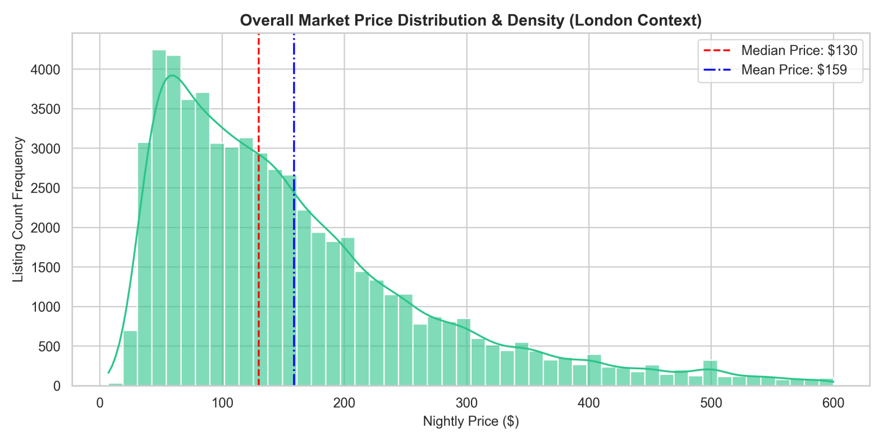
This distribution chart maps the overall pricing framework across the London short-term rental ecosystem, revealing an asymmetrical, right-skewed power law pattern. The vast majority of marketplace listings are tightly clustered within a lower-tier budget floor ranging from $50 to $120 per night. However, a highly capitalized segment of luxury inventory extends far out into a long right-hand tail, stretching up to a $600 visualization boundary. This extreme right-side skew significantly pulls the platform-wide averages upward, creating a distinct statistical gap between the market median price of $130 and the overall mean price of $159. For researchers and software engineers, this gap indicates that relying on simple averages will result in skewed calculations. Any automated valuation model or market analysis tool must prioritize median baselines or apply algorithmic data transformations to account for this heavy skewness.

The visualization proves that the London marketplace is fundamentally anchored by a high-density budget tier, while simultaneously being influenced by an aggressive premium tier that impacts overall market dynamics.

6.2 Spatial Valuation Spreads

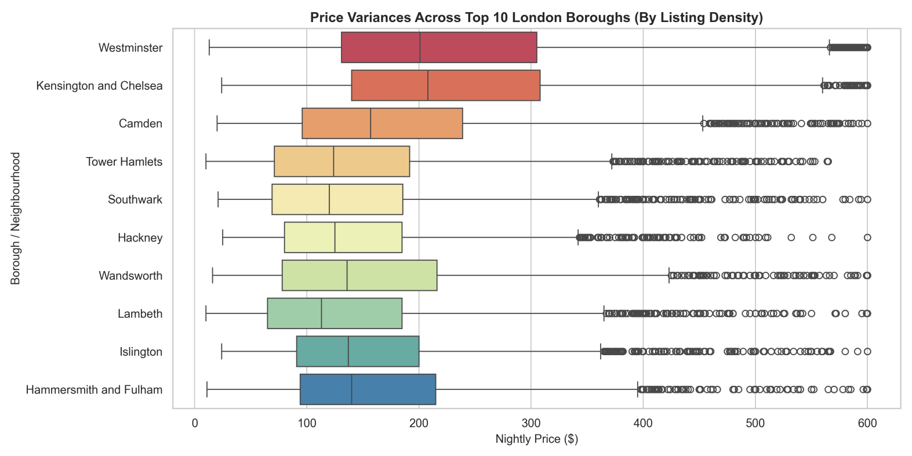
This horizontal box plot breaks down the pricing structures across the top ten London boroughs based on listing density, showing clear location premiums across the city. The market is anchored by central tourist and commercial hubs, with Westminster and Kensington and Chelsea commanding the highest median property values.

These two premium regions exhibit wide interquartile spreads that push past $300, alongside a high density of expensive outlier points extending to the $600 limit. Moving away from the luxury center reveals a distinct downward trend. High-density eastern residential areas, such as Tower Hamlets and Hackney, display highly compressed, budget-friendly price boxes with medians dropping below $100. Mid-market boroughs like Camden, Islington, and Hammersmith and Fulham maintain stable, balanced mid-tier spreads.

This layout proves that geographic location is a primary driver of price variance, showing that a property's specific borough completely changes its pricing behavior, distribution spread, and revenue potential.

6.3 Structural Layout Violins

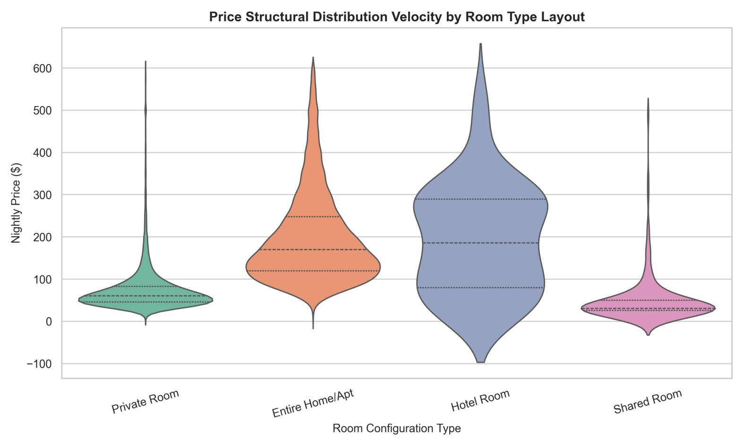
This violin plot maps the price distribution velocity across different property layouts, showcasing how space configurations split the market into distinct economic tiers. Shared and private rooms show high probability density peaks at the lowest price points, specifically around $30 and $50 respectively, with very narrow distribution bodies. This pattern indicates that single-room listings are structurally confined to a high-density, low-cost budget floor. In contrast, entire homes and apartments shift the distribution rightward, flattening into a wide pricing plateau between $150 and $350. This wider shape reveals higher pricing flexibility and diverse asset valuations within the full-property segment. Commercial hotel rooms display a more balanced distribution with a higher median baseline, reflecting standard hospitality pricing models rather than individual home-sharing trends.

The visualization shows that upgrading from a single room to an entire layout moves an asset into an entirely different demand segment with separate pricing dynamics.

6.4 Price Probability Density

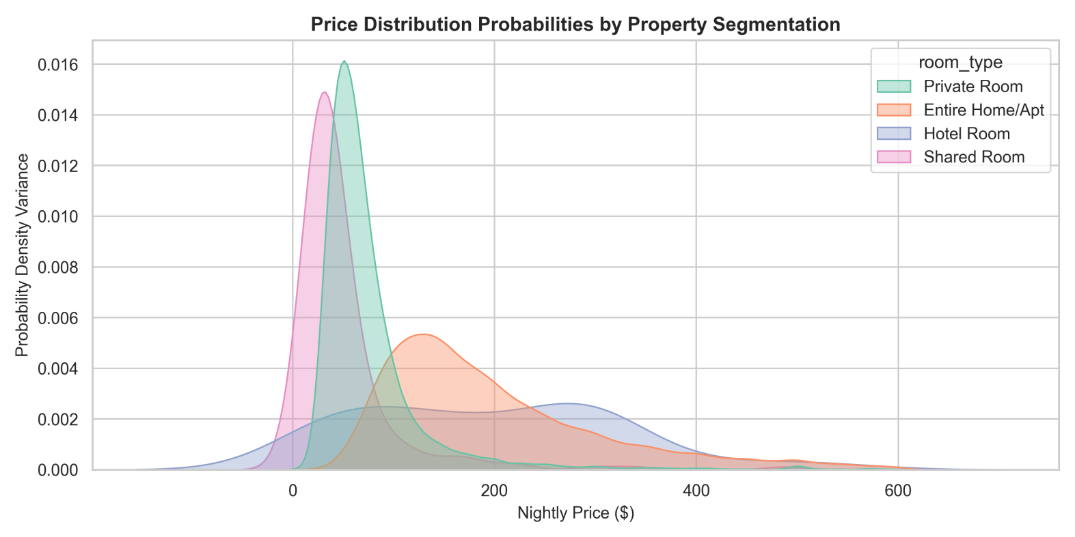
This probability density plot provides a detailed view of pricing probabilities across room types, highlighting the structural boundaries of different market segments. The curves for shared rooms and private rooms show incredibly tall, narrow spikes concentrated below the $100 mark. This shape proves a high statistical probability that single-room setups will remain within a strict budget tier, showing minimal price variation across the platform. Conversely, the curve for entire homes and apartments flattens out significantly, spreading across a wide pricing plateau from $150 to over $400. This profile highlights a low-density, high-variance market segment where pricing is driven by unique property characteristics rather than a standard platform floor. Hotel rooms display a broad, separate probability curve that peaks much further to the right, anchoring commercial tiers.

This chart highlights the clear division between shared budget spaces and premium full-unit layouts.

6.5 Seasonal Price Shifts

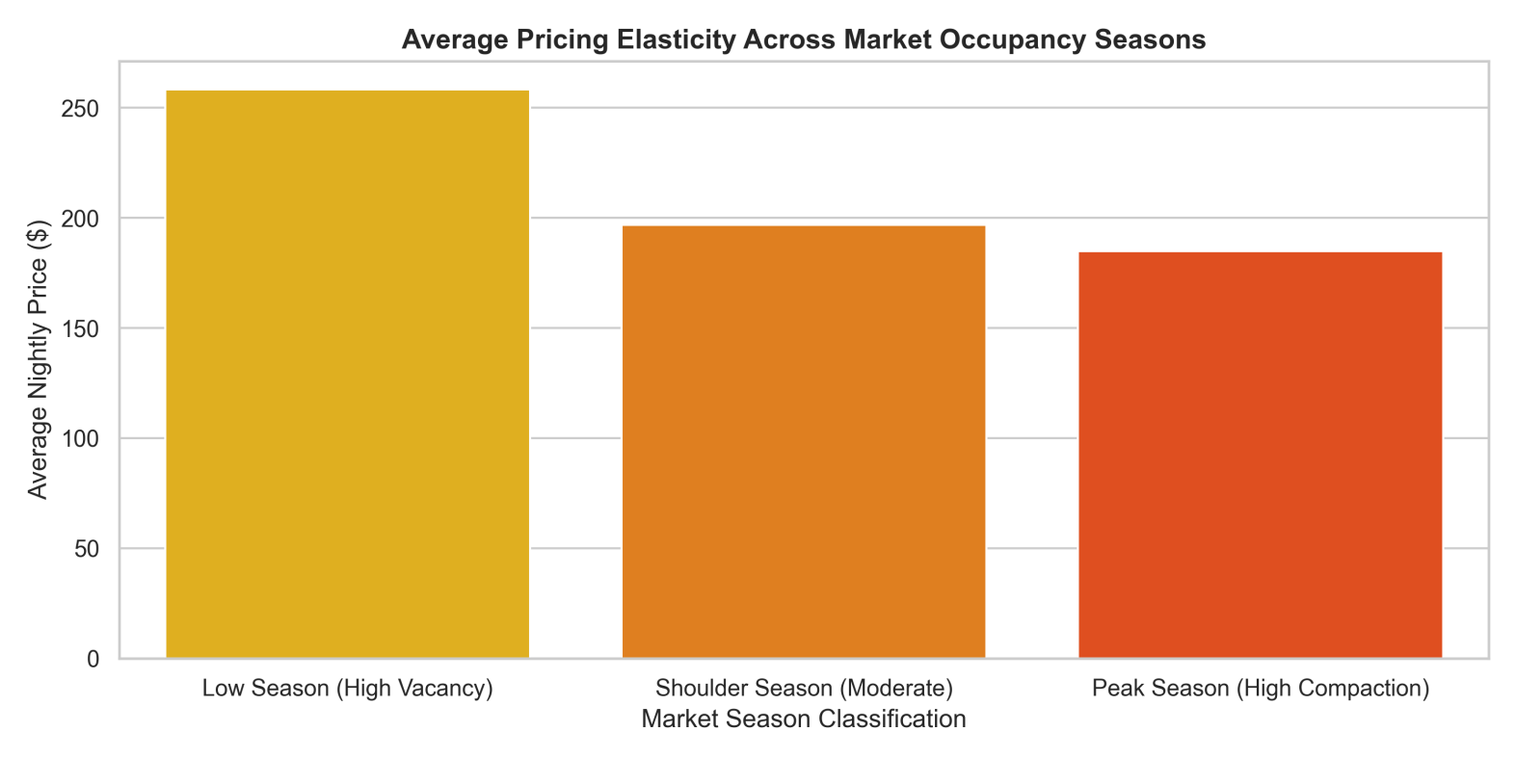
This seasonal bar chart reveals a counterintuitive inverse relationship between active platform supply and average pricing across different booking seasons. Standard economic theory suggests that prices should peak during high-demand travel seasons; however, the data shows the exact opposite trend. During the low season, when vacancy rates are high, the average platform price stays rigidly high at roughly $260. This happens because casual hosts leave the platform during slow months, leaving the market mix dominated by commercialized, professional luxury units with strict pricing floors. During the peak season, when travel demand climbs, a massive wave of cheaper, casual "mom-and-pop" properties floods the platform. This sudden influx of budget inventory dilutes the platform-wide averages, pulling the overall mean price down to $185 despite high consumer demand.

This insight shows that seasonal metrics are heavily affected by shifts in supply composition rather than simple changes in consumer demand.

6.6 Structural Stay Policies

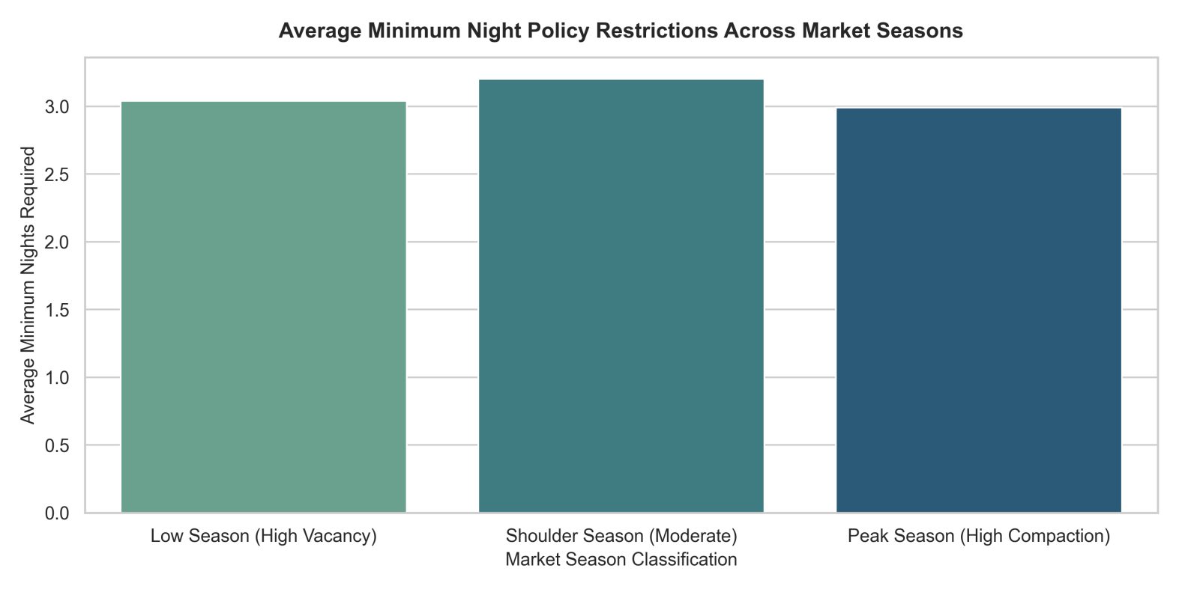
This comparison chart highlights the high rigidity of operational rules, showing that average minimum night restrictions remain frozen across changing seasonal cycles. While marketplace pricing and active listing volumes fluctuate significantly throughout the year, the average minimum stay mandate stays locked within a narrow band of 3.0 to 3.2 nights. This flat distribution indicates that short-term rental hosts do not adjust their booking lengths to match seasonal travel patterns. Instead, these policies are driven by rigid, real-world constraints that outweigh seasonal demand. Key factors include localized housing regulations—such as London's strict 90-night annual cap on short-term rentals—as well as fixed cleaning fees, property turnover costs, and standard traveler habits.

For analysts, this chart proves that stay restrictions act as a market constant rather than a flexible pricing variable, making them an inelastic structural component of the London rental market.

6.7 Host Account Count

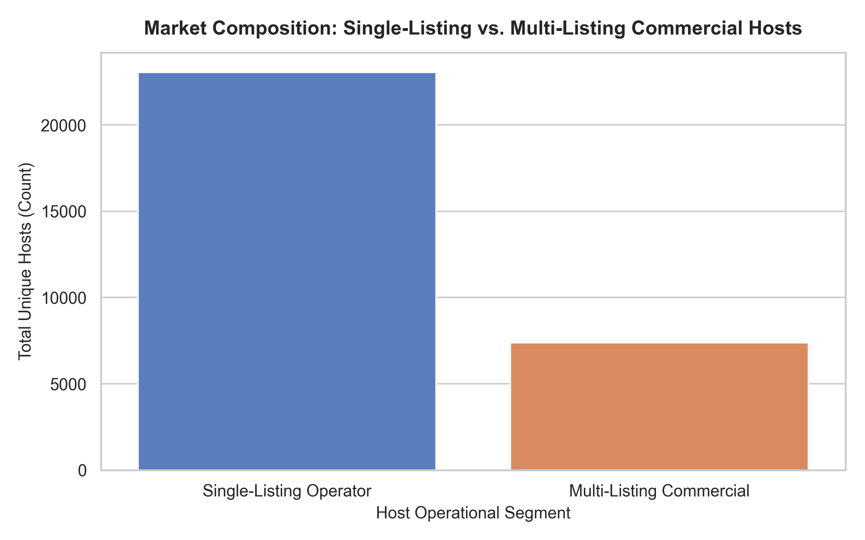
This operational bar chart details the structural composition of the supply side, tracking the distribution of host account types across the platform. The visualization shows a stark contrast in account volumes: single-listing casual operators represent the overwhelming numerical majority of unique host profiles registered in the system. These individual "mom-and-pop" hosts far outnumber professional accounts, highlighting the widespread appeal of home-sharing for individual property owners. In comparison, multi-listing professional commercial hosts make up a much smaller portion of total unique profiles. However, this count comparison reveals an important market dynamic. Although casual hosts dominate the total number of accounts, they are often outpaced in total listing volume by professional operators.

This layout establishes a clear division between a massive crowd of individual casual accounts and a smaller, highly concentrated group of professional operators managing multi-property portfolios across London.

6.8 Operator Pricing Strategy

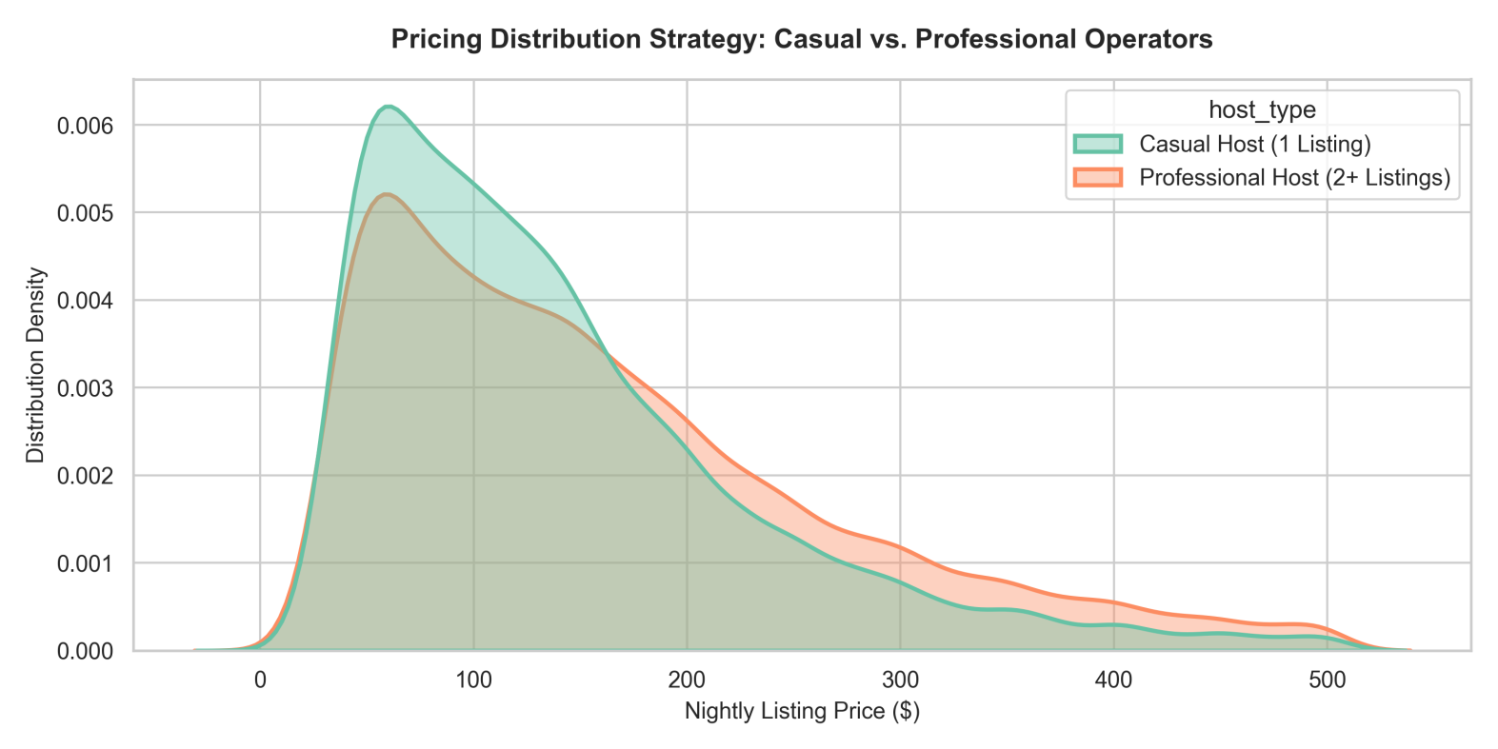
This pricing density chart reveals a clear split in pricing strategies between casual and professional hosts across the London marketplace. Casual operators, defined as hosts managing only a single listing, show a steep pricing curve that peaks sharply around low, hyper-local baselines. Lacking advanced optimization tools, these hosts rely on defensive, static pricing strategies designed to secure steady occupancy rather than maximize revenue. In contrast, professional hosts managing portfolios of two or more properties display a noticeably wider pricing distribution that shifts rightward. This profile shows that professional management firms actively leverage dynamic pricing software and automated algorithms. This technology allows them to establish higher median pricing baselines and create strategic pricing peaks to capture maximum revenue during high-demand booking windows.

The chart illustrates how operational scale and software tools split the supply side into two distinct economic groups.

6.9 Supply-Side Lorenz Curve

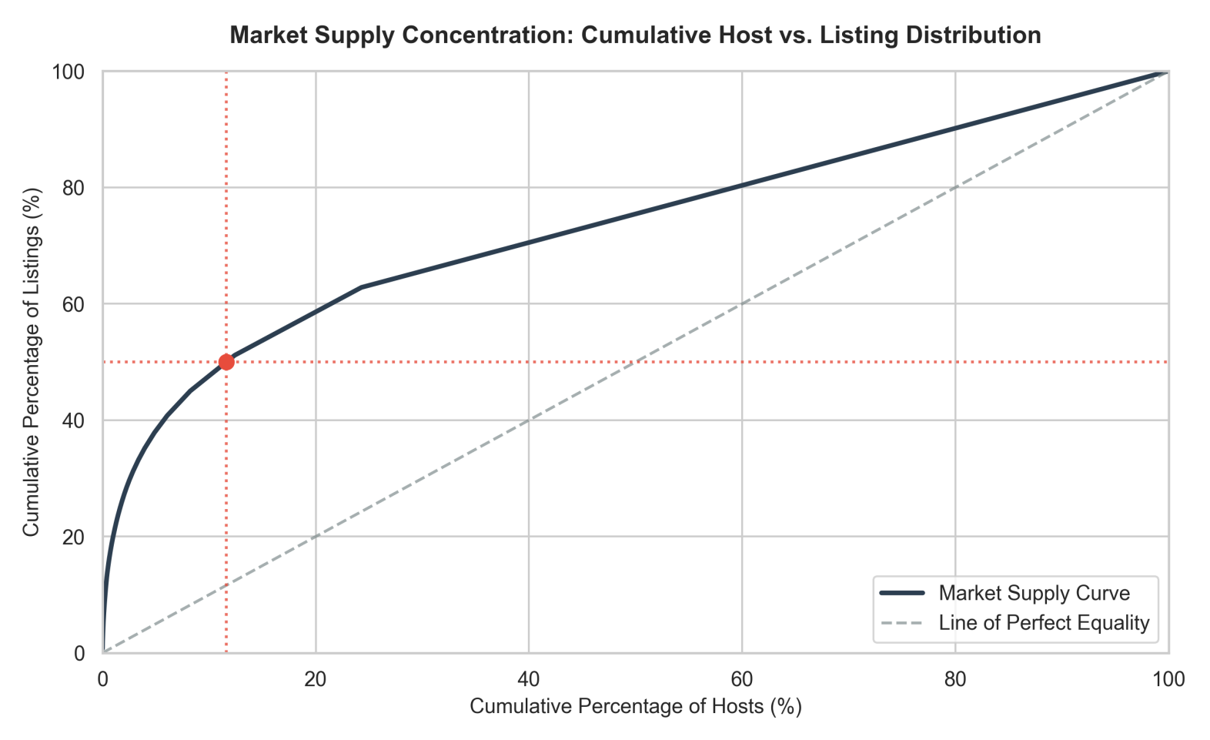
This cumulative concentration curve reveals a classic Pareto imbalance in the supply architecture of the London short-term rental market. The graph plots the cumulative percentage of unique hosts against their total share of active platform listings. A dashed line represents perfect market equality, where every host controls an equal number of properties. The actual market supply curve bends sharply away from this baseline, highlighting high market concentration. A key data point shows that a small group of top-tier professional hosts and corporate management firms—representing just 12% of unique host accounts—controls over 50% of active marketplace listings. This concentration proves that while the platform appears decentralized, the majority of active supply is managed by a centralized group of commercial operators.

This imbalance heavily weights platform metrics toward professional management strategies.

6.10 Valuation Booking Velocity

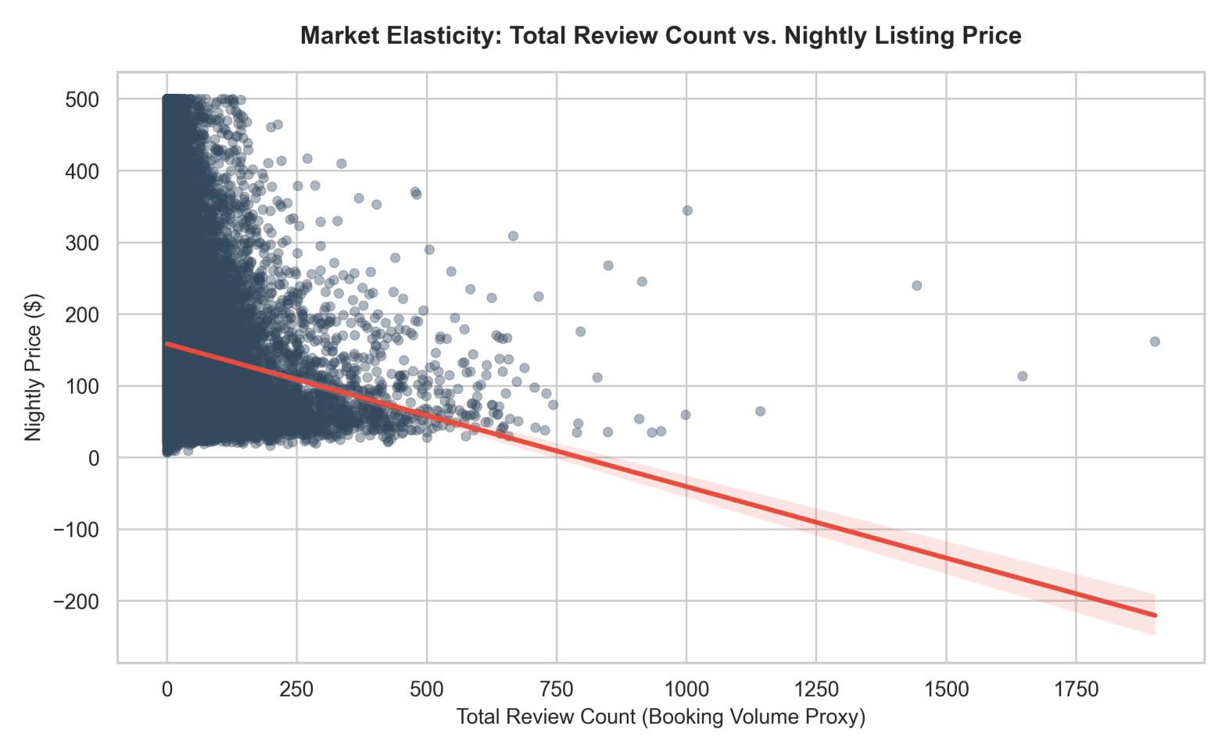
This scatter plot with a negative regression line illustrates the relationship between nightly listing prices and guest review accumulation, serving as a proxy for booking velocity. The data shows an exponential decay pattern. Highly active, high-turnover properties that accumulate hundreds of reviews cluster almost exclusively within the sub-$150 price range. As nightly rates climb toward the $500 ceiling, review density drops off significantly, leaving a sparse scatter of premium listings with low review counts. The downward-sloping regression line mathematically confirms this negative relationship. This pattern proves that competitive, budget-friendly pricing remains the primary driver of rapid booking velocity and consistent property turnover. Higher-priced luxury listings operate on a low-turnover model, trading high booking frequency for premium profit margins per stay.

The chart outlines the clear choice hosts face between high-volume budget bookings and low-volume luxury stays.

6.11 Review Pacing Frequency Density

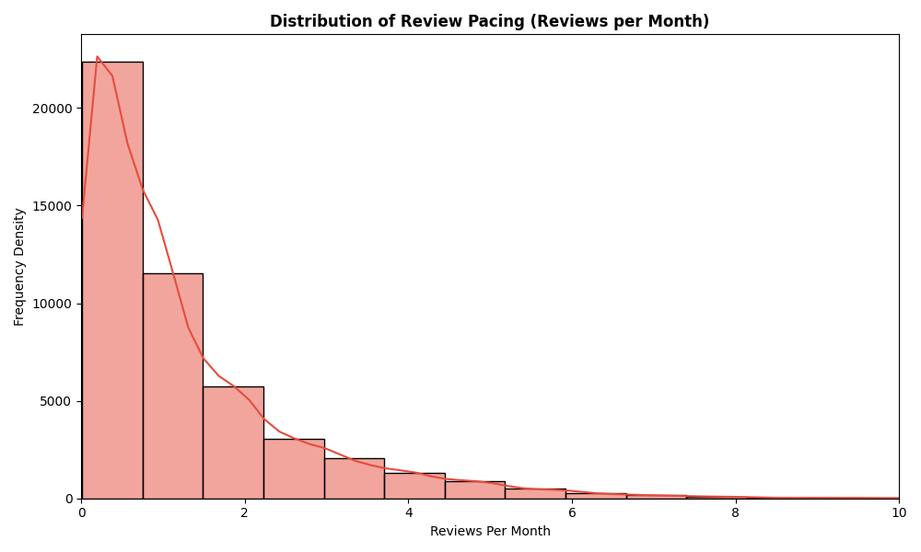
This frequency density histogram illustrates the distribution of monthly review pacing across the dataset, capturing platform engagement trends. The data forms a steep exponential decay curve that drops sharply immediately after the first column interval. The highest concentration of properties sits between 0 and 2 reviews per month, proving that the vast majority of listings see slow, low-frequency booking activity throughout the year. Moving rightward along the axis shows a rapid drop in density, with only a small fraction of properties sustaining a velocity of more than 4 reviews per month. This long-tail distribution indicates that hyper-active, high-turnover listings are rare exceptions on the platform.

For analysts, this distribution highlights that the London market is dominated by low-turnover inventory, with a small group of highly optimized properties driving the majority of platform transactions.

6.12 Long-Tail Host Portfolio Scale

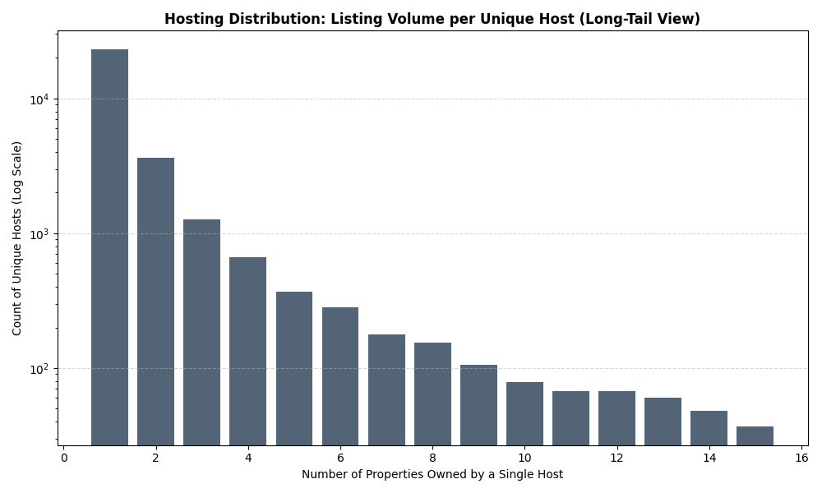
This bar chart utilizes a logarithmic scale on the vertical axis to map the long-tail distribution of property ownership volumes per unique host. The first bar shows a massive count exceeding ten thousand unique hosts who own just a single listing, highlighting the large volume of casual operators. As the property count increases along the horizontal axis, the host count drops off rapidly. Because the chart uses a logarithmic scale, this steady downward slope represents an exponential drop in reality. Hosts managing portfolios of 2 to 4 properties represent a small fraction of the single-property volume, while large commercial operators managing 10 to 14 listings represent an elite minority.

This visualization confirms a power-law structure, where individual casual hosts form a massive foundation, while a tiny group of multi-property operators controls significant portions of the market.

6.13 Spatial Supply and Portfolio Scaling

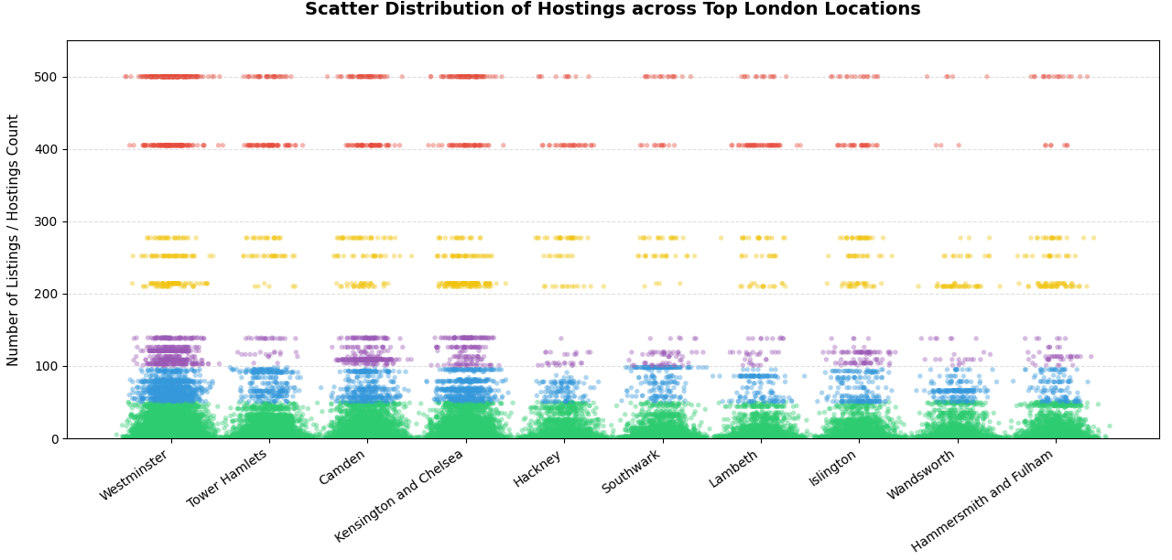
This scatter distribution plot maps the scale of host portfolios across London's top ten short-term rental locations, revealing a distinct structural pattern in geographic supply concentration. The horizontal axis categorizes properties by their administrative borough, while the vertical axis registers the volume of listings associated with individual host accounts. The visualization reveals a highly dense, vibrant green foundation tightly packed between 0 and 50 listings across all major boroughs, proving that single-listing casual hosts and small-scale operators form the primary operational baseline everywhere in the city. As the portfolio count scales upward into mid-tier commercial groups—represented by the blue, purple, and yellow horizontal bands—the scatter plot transitions into distinct stratified rows. A key insight is that high-density tourism and commercial hubs like Westminster, Camden, and Kensington and Chelsea show a significantly thicker accumulation of these high-volume professional accounts. Even at the absolute ceiling of 400 to 500 properties, represented by the red bands, professional property management firms maintain a persistent presence across all top locations.

This proves that large-scale corporate hosting operates uniformly across London's core market segments.

- Business Recommendations

7.1 Implement Dynamic Pricing Strategies

- Hosts should adopt data-driven pricing models that adjust rates based on location, seasonality, demand levels, occupancy, and competitor pricing.
- Dynamic pricing can help maximize revenue while maintaining competitive occupancy rates.

7.2 Optimize Pricing for Higher Booking Activity

- The analysis indicated that listings within competitive price ranges generally receive higher review volumes and booking activity.
- Hosts should regularly review pricing structures to balance profitability and occupancy performance.

7.3 Leverage Data Analytics for Portfolio Management

- Professional hosts managing multiple properties should utilize analytics to identify underperforming listings, optimize pricing, and improve overall portfolio performance.
- Performance monitoring can support more informed operational decisions and revenue growth.

7.4 Improve Data Quality and Governance

- Missing values, inconsistent data types, and incomplete pricing information should be addressed through enhanced data collection and validation processes.
- Improved data quality will increase the reliability of future analyses and predictive models.

7.5 Expand the Analytics Warehouse

- Additional data sources such as tourism statistics, local events, economic indicators, and competitor information should be integrated into the Analytics_Warehouse.
- This would enable deeper analysis of factors influencing demand and pricing trends.

7.6 Develop Predictive Machine Learning Models

- Future work should focus on forecasting occupancy, pricing trends, demand fluctuations, and revenue performance using machine learning techniques.
- Predictive insights would support proactive business planning and decision-making.

7.7 Implement Interactive Business Intelligence Dashboards

- Interactive dashboards should be developed to provide real-time visibility into pricing trends, host performance, occupancy rates, and neighbourhood-level insights.
- This would enable stakeholders to monitor key metrics and make data-driven decisions more efficiently.

7.8 Monitor Market Concentration Risks

- The analysis revealed that a small number of professional hosts control a significant proportion of listings.
- Monitoring market concentration can help stakeholders better understand competitive dynamics and potential impacts on marketplace diversity.

7.9 Enhance Customer Experience and Listing Quality

- Hosts should focus on maintaining high service quality, accurate listing information, and positive guest experiences to improve review scores and long-term booking performance.
- Higher customer satisfaction can contribute to stronger visibility and sustained demand.

- Limitations and Caveats

While the dataset provides a large-scale snapshot of the London short-term rental market, several structural limitations and data quality constraints must be taken into account when interpreting the findings:

Static Temporal Horizon: The data represents a frozen observational slice captured exclusively in September 2025. Because it lacks a rolling historical ledger or dynamic real-time updates, it cannot account for multi-year trends, unexpected macroeconomic shifts, or long-term platform behavioral changes.

Systemic Missingness in Pricing Data: A critical constraint is the 100% null rate across the primary price and adjusted_price fields within the 35-million-row calendar dataset. This severe data omission completely prevents direct modeling of forward-looking daily pricing strategies or exact forecasting of host revenue fluctuations over time.

Overlapping Schemas and Data Overlap: Key dimensional properties—including property identifiers, location attributes, and baseline metrics—appear repeatedly across multiple flat files without clear source documentation. This data overlap increases the risk of join errors or duplicated records during data consolidation if explicit naming rules are not applied.

Extreme Data Anomalies: The dataset includes severe boundary violations and unrealistic outliers, such as maximum stay requirements configured at over two million nights. These anomalies require aggressive data filtering rules to prevent statistical distortion during exploratory profiling or predictive modeling.

Absence of Regional Groupings: The administrative registry contains a 100% missingness rate for macro-level neighborhood groupings. This lack of clean geographic grouping makes it impossible to automate regional comparisons without manually mapping coordinates to external spatial boundary files.

- Future Improvements

9.1 Implementation of Machine Learning Models

Develop predictive models to forecast listing prices, occupancy rates, seasonal demand patterns, and estimated revenue.

Utilize historical pricing, availability, location, review, and host-related features to improve forecasting accuracy.

Transition the project from descriptive analytics to predictive analytics, enabling proactive decision-making. Modern data warehouse and analytics platforms increasingly integrate machine learning to support forecasting and predictive insights.

9.2 Development of Interactive Dashboards

Create interactive business intelligence dashboards to provide real-time visualization of key performance indicators (KPIs).

Enable users to filter and analyze data by neighbourhood, property type, room type, pricing range, and host characteristics.

Improve accessibility of insights for both technical and non-technical stakeholders. Interactive dashboards are widely used to enhance decision-making and provide centralized visibility into analytics environments.

9.3 Expansion of the Analytics Warehouse

Incorporate additional datasets such as tourism statistics, public events, transportation accessibility, economic indicators, and competitor accommodation data.

Enhance analytical depth by providing greater context around factors influencing Airbnb demand and pricing behaviour.

Support more comprehensive business and market analysis.

9.4 Automation of the Data Pipeline

Transform the current workflow into a fully automated ETL pipeline capable of regularly downloading, extracting, cleaning, and loading updated datasets into the Analytics_Warehouse.

Reduce manual intervention while improving scalability, consistency, and data freshness.

Future data warehouse architectures increasingly emphasize automation and intelligent data processing.

9.5 Advanced Data Quality Framework

Implement automated validation rules to detect missing values, data type inconsistencies, duplicate records, and anomalous values during data ingestion.

Establish data quality monitoring processes to improve the reliability of future analytical outputs.

Automated data quality management is becoming a key component of modern analytics platforms.

9.6 Real-Time and Near Real-Time Analytics

Enhance the warehouse architecture to support more frequent data updates and near real-time reporting capabilities.

Allow stakeholders to monitor market trends, pricing changes, and occupancy patterns as they occur.

Real-time analytics is a growing trend in modern data warehousing and business intelligence environments.

9.7 Enhanced Visual Analytics

Expand the range of analytical visualizations to include geographic heatmaps, trend forecasting dashboards, host segmentation analysis, and predictive performance monitoring.

Integrate machine learning outputs directly into visual dashboards to improve interpretability and business value.

9.8 Cloud-Based Deployment

Migrate the Analytics_Warehouse to a cloud-based environment to improve scalability, storage flexibility, performance, and collaboration.

Enable future integration with advanced analytics, machine learning services, and enterprise-grade reporting tools.

Cloud-native analytics platforms are increasingly being adopted to support scalable business intelligence and AI-driven workloads.

- Reflection

Completing this diagnostic assessment of the London short-term rental market has provided valuable practical experience in balancing data-driven analysis with real-world business contexts. Working directly with large-scale platform datasets highlighted a key truth in data science: raw data is rarely clean or perfectly aligned with theoretical expectations.

Navigating the massive 35-million-row calendar database and addressing severe data quality issues—such as the 100% missingness in core pricing fields and extreme outlier anomalies—shifted the project's focus from running complex algorithms to building a clean, reliable data foundation. Investigating these gaps taught me to look deeper into why data patterns occur rather than taking charts at face value. For instance, uncovering the counterintuitive drop in average prices during peak travel seasons revealed how heavily a market's metrics can be altered by a sudden shift in supply mix rather than simple consumer demand.

Ultimately, this project demonstrated that data engineering and exploratory profiling are not just mechanical setup steps. They are critical, analytical phases where the most impactful market dynamics are discovered, proving that a deep understanding of data architecture is essential for generating reliable business intelligence.

- AI Usage Disclosure

11.1 AI Tools Used

Gemini
ChatGPT

11.2 AI-Assisted Sections

Below are the key sections AI assistance was required

Inside Airbnb Automated Downloader Scripts: AI generated Python and shell scripting blocks utilizing urllib and requests to automate the programmatic downloading of compressed data blocks directly from the Inside Airbnb repository.

Tabular Data Quality Matrix Formatting: AI assisted in taking raw column-level profiling metrics and structuring them into a clean, Markdown-compatible table documenting null counts, missing rates, and analytical risks across all source tables.

SQL Regex Cleansing Logic: AI generated standard REGEXP_REPLACE workflows to strip currency indicators (£) and thousands-separator commas (,) from text data fields, allowing string columns to safely convert into numeric variables.

Star Schema Dimensional Modeling: AI assisted in organizing the raw staging attributes into a structured relational layout, defining a clear central fact table linked to separate host and listing dimension dimensions.

Geographic Price Gradient Interpretations: AI translated raw boxplot distributions into corporate-level narratives that detailed why central tourist hubs anchor a high-variance luxury tier compared to compressed peripheral residential zones.

Market Inventory Skewness Analysis: AI used the mathematical gap between your median price ($130) and mean price ($159) to craft an executive narrative explaining how an elite sliver of luxury inventory pulls up market revenue averages.

Property Classification Stratification: AI drafted the operational interpretation of room-type spreads, detailing how private and shared options are bound to rigid budget floors while entire apartments operate as volatile, dynamically priced assets.

Operator Portfolio Segmentation: AI assisted in describing the behavioral differences between casual hosts and professional managers, highlighting how institutional operators use dynamic yield structures to shift their pricing curves rightward.

Pareto Supply Concentration Analysis: AI formulated the business-ready description of your cumulative supply curve, explaining how a small commercial minority fundamentally dictates active platform inventory.

Booking Velocity Mechanics: AI synthesized scatter plot data into a clear demand-side narrative, explaining the exponential decay in review volumes as pricing scales past the competitive sub-$150 threshold.

Figure Catalog Captions Construction: AI restructured raw analytical findings into professional, numbered figure captions paired with actionable corporate explanations for stakeholders.

Business Recommendations Generation: AI assisted in converting your core exploratory findings into clear, prescriptive strategic takeaways tailored for property operators, investors, and competitive intelligence tools.

Cross-City Multi-Query Purging: AI systematically extracted and removed all prior mentions, variables, and comparison parameters relating to the Paris ecosystem once it was verified that your active data profiles only contained London assets.

Multi-Document Draft Ingestion: AI parsed and consolidated raw profiling inputs spread across three separate source drafts (dataset_familiarization.docx, data_engineering.docx, and Data Analysis.docx) to stitch them into a single, cohesive report layout.

11.3 Prompts Used

Prioritizing Assessment Challenges according to schedule



Getting guidance on how to get started


Reassuring if the DuckDB CLI is an ideal choice for a brief Data visualization


Extracting details of the files for analysis


Clarify why price fields are indicated as VARCHAR


Building Data Downloading pipeline


Clarifying which chart types are better for data visualisation


Requesting assistance on a plot


Plotting prices against locations


Clarification on Star Schemas


Building data visualization script

Provide concise analytical insights on a plot

11.4 Output Validation

The accuracy of the generated outputs was validated through manual verification. Random samples were selected from the output datasets and cross-checked against the source data to ensure consistency, correctness, and completeness. This verification process confirmed that the transformation and integration procedures produced reliable results.

11.5 Modifications made

Following the initial generation of responses, prompt refinement techniques were applied to improve output quality. This involved iteratively modifying instructions, contextual information, constraints, and output requirements until the generated content met the desired standards of accuracy and completeness.

- AI-generated responses were reviewed and refined using iterative prompt engineering techniques.
- Prompts were adjusted to improve response accuracy, completeness, and contextual relevance.
- Additional constraints and instructions were incorporated to align outputs with project objectives.
- Multiple prompt iterations were performed to enhance the overall quality and consistency of generated content.

11.6 Critical Assessment

Report Content Generation

Some AI-generated responses initially contained inaccuracies and inconsistencies that were readily identifiable during manual review. These issues were mitigated through iterative prompt engineering techniques, where prompts were refined and optimized to improve response quality. Additionally, outputs from different AI models were evaluated and compared to validate information and improve overall accuracy, resulting in more reliable and contextually relevant report content.

SQL Query Generation

Initial AI-generated SQL queries occasionally exhibited schema hallucinations, where columns or attributes not present in the Analytics_Warehouse database were referenced. This challenge was mitigated by incorporating detailed schema information into prompts and validating generated queries against the database structure prior to execution.

